# **ELG v1.0.0 Deployment Instructions**

## Deployment prerequisites

* Cloud.gov access and specifically ***epa-surface-water*** organization (i.e., OWTBX) deployment permissions.
* Version 7 of the Cloud Foundry Command Line Interface
* A web browser with internet access

## Deployment steps

1. Download the latest application release from <https://projects.erg.com/water/cooper/OWTBX/ELG/v1_0_1/elg-v1.0.1.zip>.
2. Unzip the release file.
3. Use the file explorer to navigate to the unzipped application location. The contents of the folder should look like

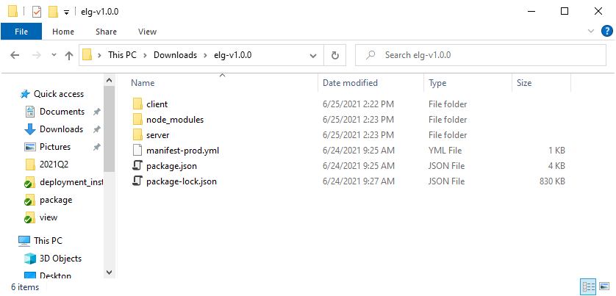

1. Open a command prompt and use the cf CLI to log in to Cloud.gov. Once authenticated, switch your target to the ***epa-surface-water*** organization (i.e., OWTBX) and to the ***owtbx-elg-prod*** space.
   * + - cf login -a api.fr.cloud.gov --sso
       - cf target -o epa-surface-water -s owtbx-elg-prod
2. Use the command console to deploy the application to Cloud.gov using the CLI
   * + - cf push -f manifest-prod.yml -p . --strategy rolling
3. Using a web browser, verify the application is available via the standard route and the mapped URL
   * + - <https://owapps.epa.gov/elg/>
4. Notify the customer and technical support contractor the application is ready for testing.